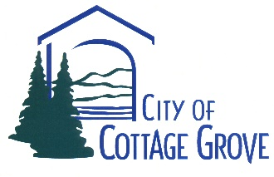

April 27, 2020

RE: Notice of Intent to Award

**SAFE ROUTES TO SCHOOL & FILLMORE STORMWATER OUTFALL PROJECT - 2020 PROJECT**

Dear Bidder:

Pursuant to City Public Contracting Rule (City Rule) 137-049-0395, this Notice of Intent to Award to the above referenced project shall be posted on the City's website.

The City of Cottage Grove received four (4) responsive bids for the work associated with the "SAFE ROUTES TO SCHOOL & FILLMORE STORMWATER OUTFALL PROJECTS -2020". The bids were opened on Thursday, April 24, 2020 at 2:00 p.m. The lowest responsive bidder was Wildish Construction Co. with an overall bid of $ 3,487,237.50.

City staff will recommend award of the contract for SAFE ROUTES TO SCHOOL & FILLMORE STORMWATER OUTFALL PROJECT - 2020" to Wildish Construction Co. and the City Council will make its decision at its regular council meeting on April 27, 2020.

Protests of the City's Intent to Award must be filed within seven (7) days after the date of issuance of this notice. Any such protest must conform to City Rule 137-049-450(4) or will not be considered by the City. Direct such protests to:

Ron Bradsby, P.E., P.L.S.

City of Cottage Grove

Engineering Division

400 E. Main Street

Cottage Grove, OR 97424

If you have any questions, please contact Ron Bradsby at (541) 942-3349 or

engineering@cottagegrove.org